

|  |  |
| --- | --- |
| LAB 3  CONTROL STRUCTURE AND ARRAY | |
| COURSE CODE | **DAT 21303** |
| COURSE NAME | **WEB DEVELOPMENT** |
| FACULTY | **CENTRE OF DIPLOMA STUDIES (CeDS)**  **DEPARTMENT OF INFORMATION TECHNOLOGY** |
| STUDENT NAME | **QAIREL QAYYUM BIN MUHAMAD RIDHUAN**  **(AA212363)**  **WAN MUHAMAD ALIF FIRDAUS BIN WAN HANAFI**  **(AA210292)** |
| SECTION | **6** |
| LECTURER NAME | **MISS NADIA** |
| SUBMIT DATE |  |

**Question 1:** Based on Table 1.0 is about a range of marks and student grade. By using if else

control structure create a simple program to determine range of marks and grades.

­Table 1.0: The Range of Mark and Grade

|  |  |
| --- | --- |
| **Marks** | **Grade** |
| 70 – 100 | A |
| 60 – 69 | B |
| 50 – 59 | C |
| 40 – 49 | D |
| 0 – 39 | F |

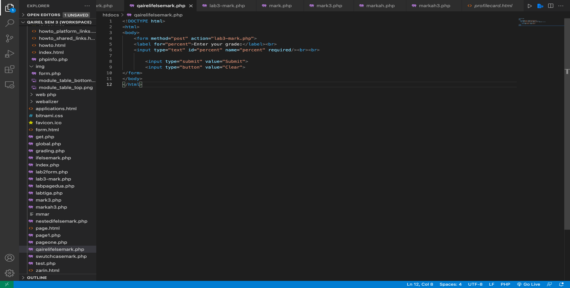

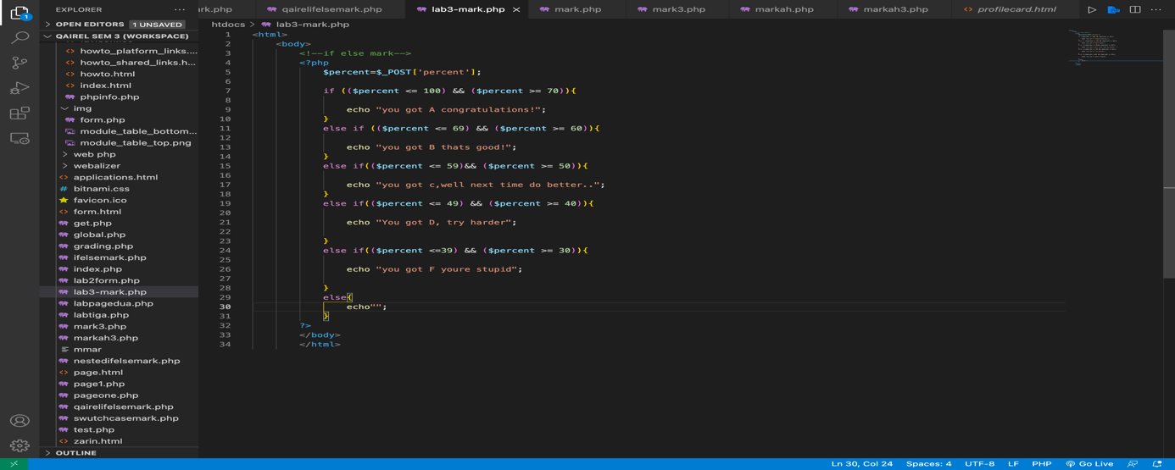

<!DOCTYPE html>

<html>

<!--percent submission slot-->

<body>

<form method="post" action="lab3-mark.php">

<label for="percent">Enter your grade:</label><br>

<input type="text" id="percent" name="percent" required/><br><br>

<input type="submit" value="Submit">

<input type="button" value="Clear">

</form>

</body>

</html>

<html>

<body>

<!--if else mark-->

<?php

$percent=$_POST['percent'];

if (($percent <= 100) && ($percent >= 70)){

echo "you got A congratulations!";

}

else if (($percent <= 69) && ($percent >= 60)){

echo "you got B thats good!";

}

else if(($percent <= 59)&& ($percent >= 50)){

echo "you got c,well next time do better..";

}

else if(($percent <= 49) && ($percent >= 40)){

echo "You got D, try harder";

}

else if(($percent <=39) && ($percent >= 30)){

echo "you got F youre stupid";

}

else{

echo"";

}

?>

</body>

</html>

THE OUTPUT

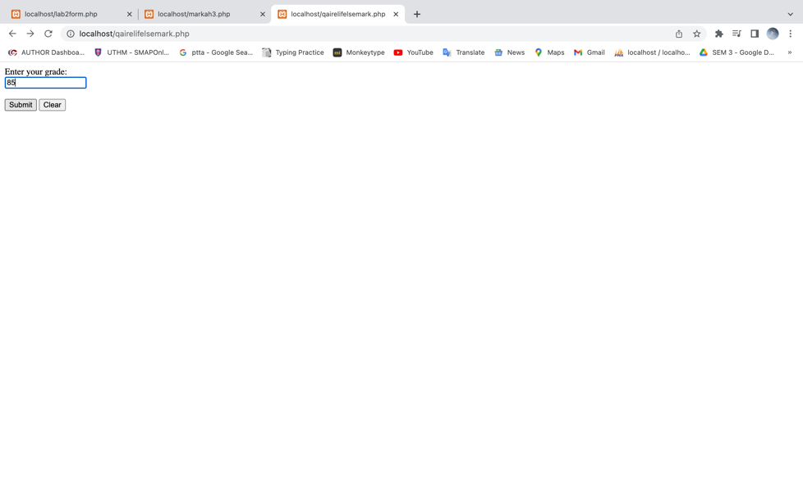

**Question 2:** Escalate the answer from question 1. Change from if else to switch case

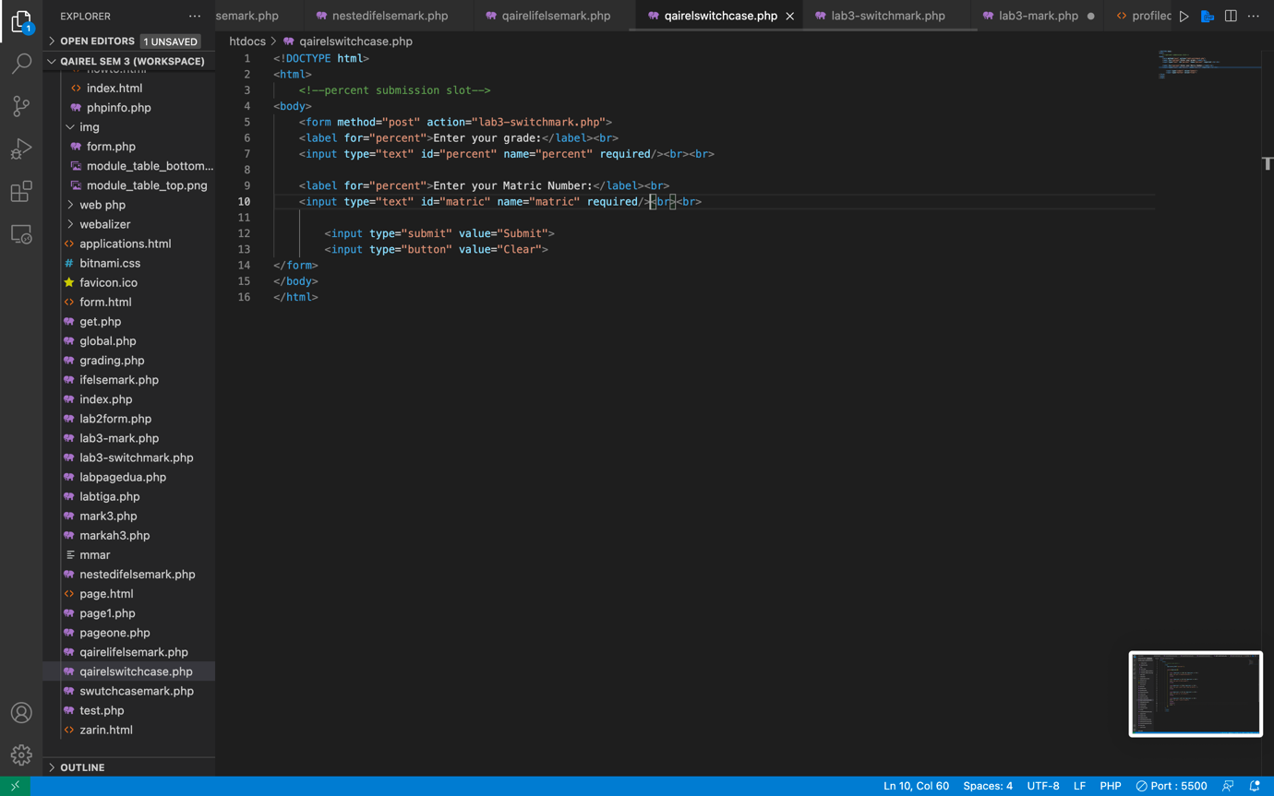

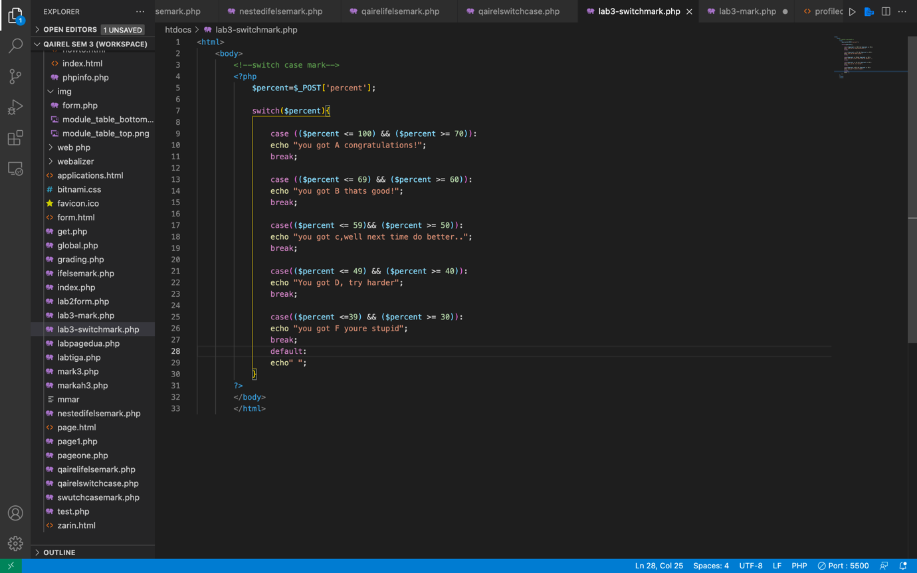

<!DOCTYPE html>

<html>

<!--percent submission slot-->

<body>

<form method="post" action="lab3-switchmark.php">

<label for="percent">Enter your grade:</label><br>

<input type="text" id="percent" name="percent" required/><br><br>

<label for="percent">Enter your Matric Number:</label><br>

<input type="text" id="matric" name="matric" required/><br><br>

<input type="submit" value="Submit">

<input type="button" value="Clear">

</form>

</body>

</html>

<html>

<body>

<!--switch case mark-->

<?php

$percent=$_POST['percent'];

switch($percent){

case (($percent <= 100) && ($percent >= 70)):

echo "you got A congratulations!";

break;

case (($percent <= 69) && ($percent >= 60)):

echo "you got B thats good!";

break;

case(($percent <= 59)&& ($percent >= 50)):

echo "you got c,well next time do better..";

break;

case(($percent <= 49) && ($percent >= 40)):

echo "You got D, try harder";

break;

case(($percent <=39) && ($percent >= 30)):

echo "you got F youre stupid";

break;

default:

echo" ";

}

?>

</body>

</html>

**Question 3:** By using Foreach create and populate data from given array into table:

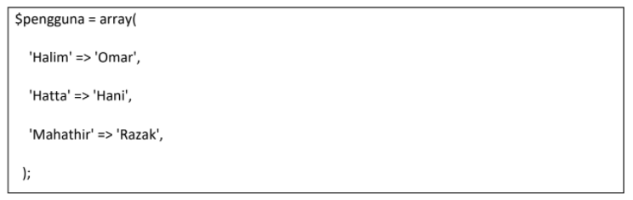

<!DOCTYPE html>

<head>

</head>

<body>

<?php

$array=array('halim', 'omar' , 'Hatta' , 'Hani' , 'mahathir', 'razak' );

$assoc= array('Halim'=>'omar', 'Hatta'=>'Hani', 'Mahathir' => 'razak');

//foreach($arr as $name){

//echo $name. '</br>';

// }

foreach($assoc as $key=>$name){

echo $key. ' => ' .$name. '<br/>';

}

?>

</body>

</hmtl>

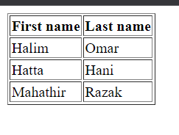

<!DOCTYPE html>

<html lang="en">

<head>

<meta charset="UTF-8">

<title>Document</title>

</head>

<body>

<?php

$name=array(

"<b>First name<b>"=>"<b>last name<b>",

"Halim"=>"omar",

"hatta"=>"hani",

"Mahathir"=>"razak"

);

?>

<html>

<head>

<title></title>

</head>

<body>

<!--create table-->

<table border="1">

<?php foreach($name as $x=>$y):?>

<tr>

<td><?php echo ($x);?></td>

<td><?php echo ($y);?></td>

</tr>

<?php endforeach;?>

</table>

<!--td is table -->

<!-- tr is next row-->

<!-- x is first word-->

<!-- y is second word-->

</body>

</html>

**Question 4:** Provide differentiation between forloop and foreach. Your explanation must be

included by example.

The JavaScript for loop is used to iterate through the array or the elements for a specified number of times. If a certain amount of iteration is known, it should be used. Meanwhile for each loop is also used to loop through arrays, but it uses a function differently than the classic “for loop”. It passes a callback function for each element of an array together with the few parameters. For each is a newer loop but for loop is more preferred as it has faster performance, can use break statement and works with await keys. However, in some cases, people might will use for each loop.

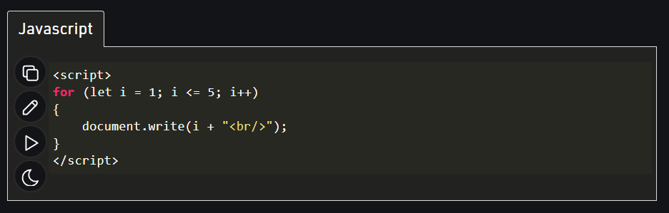

For loop

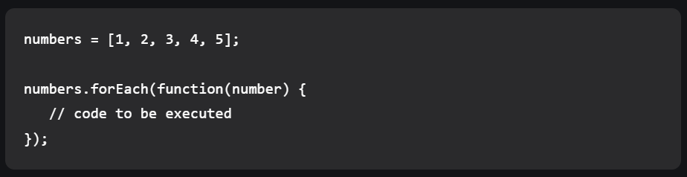

For each loop

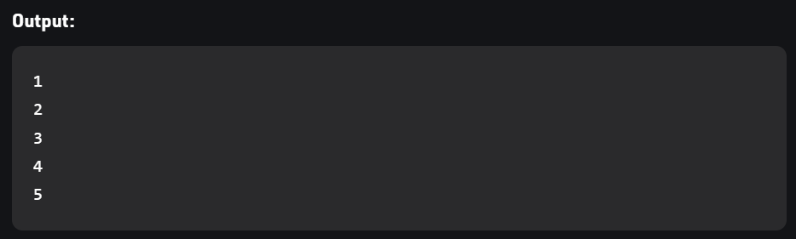

Same output but different codes